INFO 116 - Semantic Technologies

-Exploring the semantic web

# 

By 213903, 218599, 229658, 222447, 231167

Department of Information Science and Media Studies

University of Bergen

November 2014

(This page left blank intentionally)

## Introduction

In this written report, you are going to get an understanding of what has been accomplished, get a little peek into our different solutions, and how we came to the conclusions that were made. The report will go through what each member of the group has contributed, as well as a walkthrough of our methods creating the ontology. There will also be an explanation on which data sources are used to gather the information acquired for both the ontology and markup. We will show some example queries to what our ontology could be used for. By using our added semantics, anyone who want can use our added information and put it into their own semantic database.

## What we did

In the beginning when we got the term paper there were a lot of talk on how we were going to take on the problem. We had to read the assignment a couple of times to figure out what had to be done, who should do what, and where to start. After the planning was finished, we could finally start on the main part of the term paper. One of the members started working on the ontology and had it finished before the next group meeting. This made it so that we could start with the markup, which involved RDFa and JSON+LD. We picked five courses that we found had enough variety between them, and were interesting enough to write about and would gild for some good markup. Two of the members took care of the RDFa, and were working together to find the best solution for our ontology. In the meantime, another member wrote the JSON+LD files, which we later added to the .html files. This is mainly what took time during the assignment. We had to redo our ontology a couple of times because of some lack of content, and to correct some wrongs to make it work correctly. Logs were written after each labmeeting, to see who came and what had been done. After all this had been done, we found some interesting queries we could get answers to using our ontology. These were written in SPARQL and the whole team contributed in finding the most interesting queries.

We ran into a couple of problems when we tried to implement the SPARQL queries. The problems which occurred happened since the whole ontology missed some crucial details. All of the individuals and data properties were missing, and we were only a few days before the deadline.

## Ontology

As with any ontology, this is an ontology of things. We have a hierarchy with all the subclasses we found necessary. They are divided after what we found the best, and placed in each category without any duplicates. Each course is linked with the different subclasses that fits and is needed by that class.

BASV-INFO is the superclass for the main part of the ontology. All its children are what is needed to get that degree. This includes all the courses you can take, all the different subject areas you are going to have and learn, and all the different course info connected to the subjects. Although, not all the information about the different courses are implemented. Some of the courseinfo would just be busywork, which is not necessarily needed. Of course it would be of some use to have it all, but it would just take up to much of our time.

The courses are divided after introduction, exphil, choice, and specialization. Introduction has the different 100-courses that are needed for taking the bachelor, while the exphil class has the two different exphil-courses that you can choose for this bachelor. In the specialization there are all the specialization courses. Choice has all the 2xx-courses, which you can choose to have in the fifth and sixth semester, or before if you choose so or are missing some studycredits. These are all connected to their different subject areas, what kind of examination types there are, their schedule and what kind of assignments you can expect.

Parentclass to BASV-INFO is the institute where the tutoring is going to take place. We’ve included some different institutes, so if there should be another degree added to the ontology, it won’t be necessary to do a whole lot of work to put it in.

We disjointed the subjects from each other in the choice and specialization. Everytime we added another siblingclass to a course, it also got all the information from it's siblings added to it. If we removed the information from one of the classes, they all lost it, but it all worked after the classes were disjointed.

An individual is an instance of the class course, and it’s connected together with the instance of the other class. This gave us a lot of trouble when writing the queries, since in the beginning we only used classes, and could not understand why they were not doing as told. When we added this information, it all ran smoothly.

All individuals in the members list, is just for the normal course in taking the bachelor. Even though, the course can still be taken in both the autumn and spring semesters.

## Data Sources

We used SPARQL as our protocol and query language. This is specifically design to be used with semantic for extracting data sources. All of our data sources are derived from the uib.no webpage. We used specifically the webpage for the information science study to gather our data. The JSON+LD files added some of the attributes from schema.org.

## What can the website do with the added semantics?

In our assignment, we have added semantics to the webpage via the use of RDFa’s and JSON-LD.

**RDFa** (Resource Descrition Framework in attributes) is mainly a recommendation by W3C that lets you provide a set of attributes that carries metadata in XML documents. The attributes within RDFa are as follows: **about** (the resource of the metadata specified by an URI or CURIE), relationship and reverse-relationships (**rel and rev**), partner resource specified by **src, href, and resource**. **Property** (lets you specify the property for the elements content or the partner resource). [1]

There are also optional attributes that lets you do additional specifications within other attributes. These are the following optional attributes:|

**Content -** Overrides the elements content when the property attribute is used. **Datatype** - An attribute that lets you specify the data type of the text in the property attribute. **Typeof** - An attribute that specifies the type of RDF in the partner resource or subject.

**JSON-LD (**Javascript Object Notation for Linked Data) is basically a format for transporting linked data to create a “tidier” and organized web. The essential priority of JSON is to convey data between a server and a web application. Linked data is easiest explained by saying you share interlinked, structured data as to connect data with other relevant data. All in all it is when data from different sources gets connected both data-linked wise and semantically. This is done in a way that both the computer and person reading the data can understand it and interpret the meaning behind it. [2]

What can the website do with the added semantics?

With our added semantics, the website can basically answer basic queries about the various subjects. How many of the subjects that are during the autumn, how many subjects that are during the spring and has 10 studypoints, which ones that contains programming, all courses that are in english, if there subjects with different group projects or mandatory attendance etc.

## Some examples of markup

### INFO100 – RDFa markup

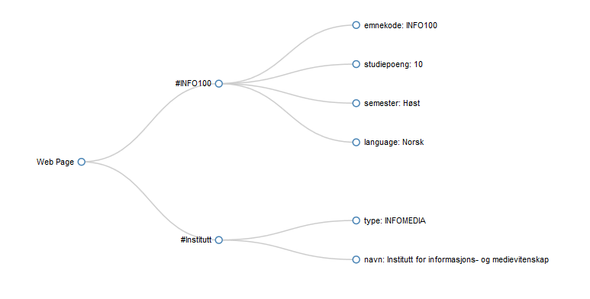INFO116 – RDFA markup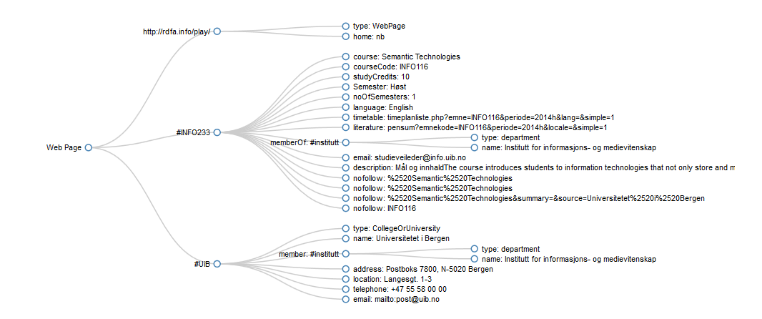INFO233 – RDFa markup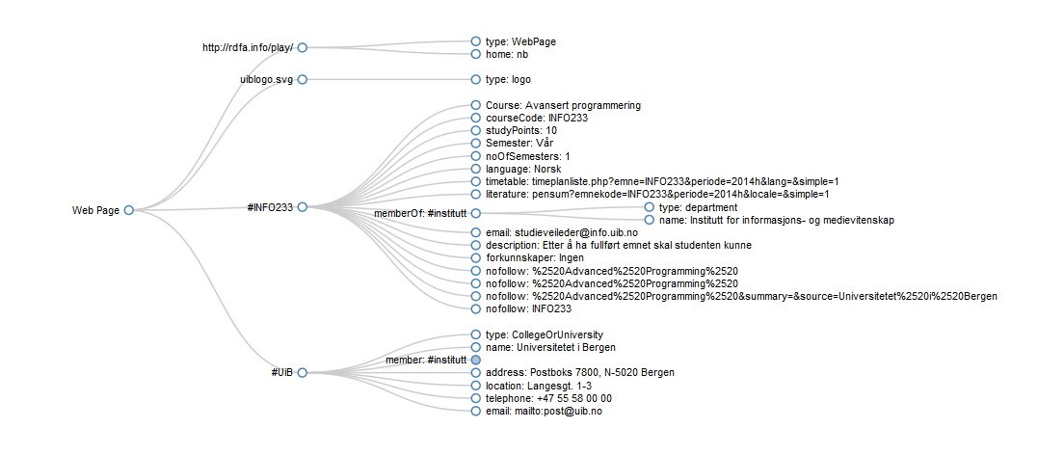

## SPARQL Queries

PREFIX rdf: <http://www.w3.org/1999/02/22-rdf-syntax-ns#>

PREFIX owl: <http://www.w3.org/2002/07/owl#>

PREFIX xsd: <http://www.w3.org/2001/XMLSchema#>

PREFIX rdfs: <http://www.w3.org/2000/01/rdf-schema#>

PREFIX : <http://www.semanticweb.org/simen/ontologies/2014/9/infovitFINAL#>

1#Displays all possible subjects in BASV-INFO-program

SELECT  ?subject

WHERE {

{?subject rdfs:subClassOf :Choice. }

UNION

{?subject rdfs:subClassOf :Exphil.

}

UNION

{?subject rdfs:subClassOf :Introduction.

   }

UNION

{?subject rdfs:subClassOf :Specialization.

   }

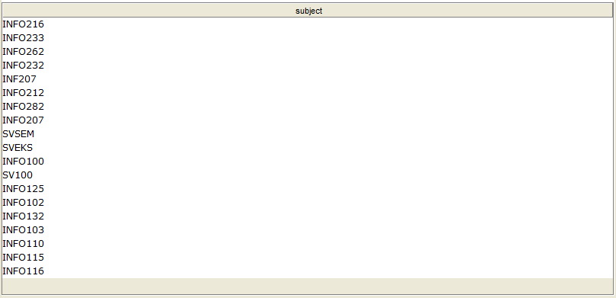

2#Which ones has programming

SELECT ?subjName

WHERE {

?subjName :covers :Programming.

}

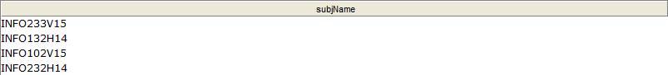

3#Covers databases but NOT querylanguage

SELECT ?subjName

WHERE {

{?subjName :covers :Database} MINUS {?subjName :covers :Theory}

}

https://lh5.googleusercontent.com/YaQw6bPoAkzQlriD7q2J05teUNzZKoKCXU4_XJqMAQoFTUHKug1tucoirMo9UwBSWc62rf8JpCLnEISVxPosPmeELSyCIEXae7-Q8tcMzHcs1KV8nRLGYgOX8oFknZ4_Ow

4#How many groupprojects or mandatoryAssignements

SELECT   ?courseName ?groups ?assignments

WHERE {

   {?groups a :GroupProject.

   ?courseName :has ?groups}

   UNION

   {?assignments a :MandatoryAssignments.

   ?courseName :mustComplete ?assignments

}

}

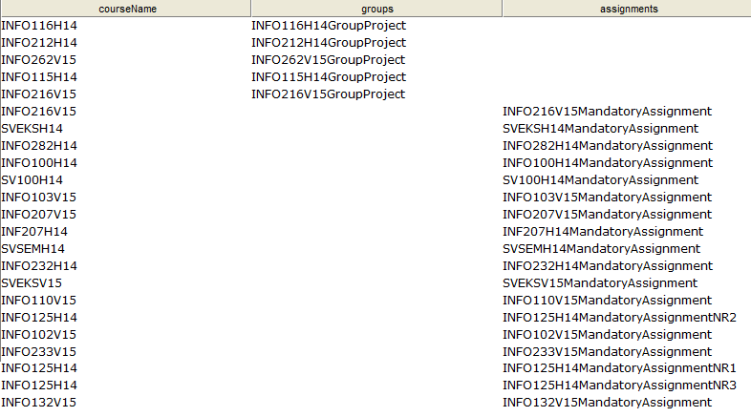

5#Which courses are at autumn

SELECT ?courseName

WHERE {

?courseName :isAt :Autumn .

}

ORDER BY ?courseName

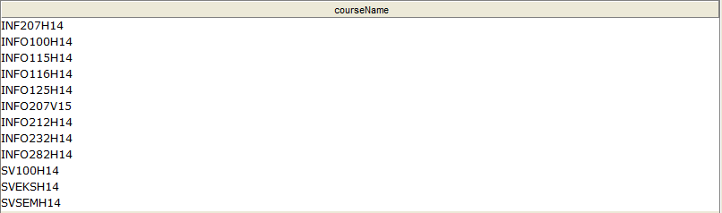

6#Covers any of them both data-architecture and algorithms

SELECT ?subjName

WHERE {

?subjName :covers :Algorithms .

?subjNm :covers :Data-Architecture .

FILTER (?subjName = ?subjNm)

}



7#All courses at spring with 10 studypoints

SELECT ?subject

WHERE {

    ?subject :isAt :Spring;

   :has :STC10.

}

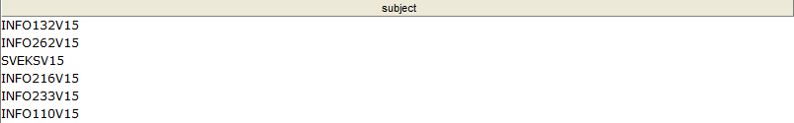

8#Which subject areas do you learn from the course

SELECT ?subjArea

WHERE {

?subjArea a :Subject-Areas .

  ?subject :covers ?subjArea.

FILTER(?subject = :INFO110V15)

}

https://lh4.googleusercontent.com/k4a6oWDHzsGvz5TluxaTgVtVznKDrYjIRdjc4pMl5Bis8NPz82XKRfA36VOt5dQyM5dAnPNiWN4E1wHaD-mr5rGg6ROOCFuUh0uL1XXp0nb0rTa837CNS38e1_MBS13zjw

9#All courses that are in English

SELECT ?subjName

WHERE {

?subjName :is :English .

}

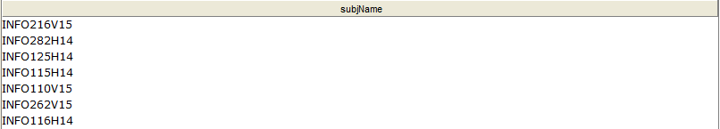

10#Which ones has programming at Spring

SELECT DISTINCT ?subjName

WHERE {

{?subjName :covers :Programming} UNION {?subjName :isAt :Spring.}

}

ORDER BY ?subjName

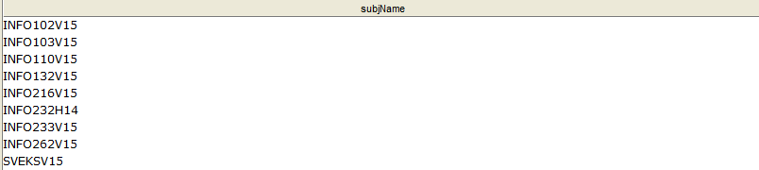

## Sources:

[1]Authors: Ben Adida and Mark Birbeck, RDFa (Last edited The 12th of April, 2014), [Internet], Available on: http://en.wikipedia.org/wiki/RDFa

[2]Authors: Manu Sporny, Dave Longley, Gregg Kellogg, Markus Lanthaler, Niklas Lindstrom, JSON-LD (Last edited on 22 May 2014), [Internet], Available on: <http://en.wikipedia.org/wiki/JSON-LD>